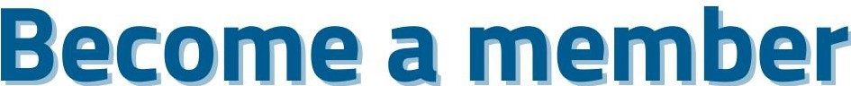
LEMON
LEARNING EUROPE through MOBILITIES and OPPORTUNITIES NETWORK

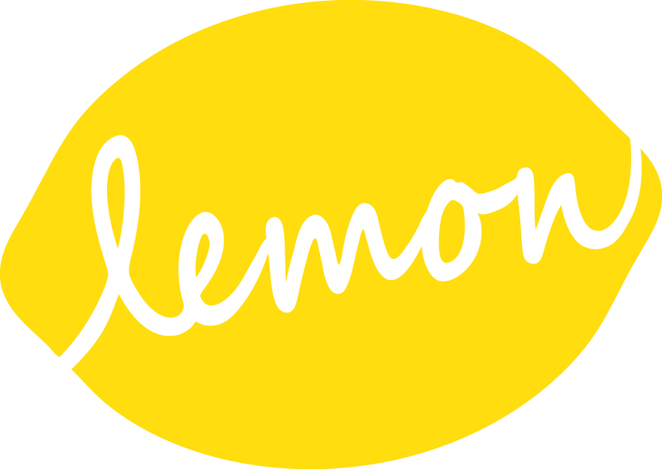

Build a Europe where young people are empowered to learn, grow, connect, and contribute to a better, more sustainable future!

Together, let's make youth mobility and European education a reality for all, while protecting our planet!

L.E.M.O.N.'s Manifesto for Youth Mobility and European Education: Empowering Young People to Build a Sustainable Future

We, the L.E.MO.N. federation, a network of organizations dedicated to fostering youth mobility and European education, believe in a future where all young people are equipped with the knowledge, skills, and opportunities to become active and engaged European citizens who contribute to a sustainable world.

We envision a Europe where young people:

- Embrace mobility as a tool for personal and professional growth: develop intercultural competence, adaptability, and a global perspective through diverse mobility experiences, while minimizing their environmental impact.

- Become informed and engaged citizens: understand the complexities of the European Union, its history, values, and challenges, and actively participate in shaping its future, with a strong commitment to sustainability.

- Champion diversity and inclusion: value and respect cultural differences, promote social cohesion, and contribute to building a more inclusive and equitable society, recognizing the interconnectedness of social and environmental justice.

- Lead the way towards a sustainable future: develop critical thinking skills, embrace environmental responsibility, and actively contribute to building a more sustainable Europe through conscious consumption, ecological awareness, and responsible travel practices.

Our commitments:
- Provide accessible and high-quality mobility opportunities: offer a diverse range of programs that cater to different needs and interests, ensuring inclusivity and accessibility for all young people, while prioritizing sustainable travel options and minimizing environmental impact.

- Integrate European education and sustainability into all our programs: foster critical thinking, intercultural dialogue, and active citizenship through innovative and engaging learning experiences that promote environmental awareness and responsible behavior.

- Empower young people to become agents of change: support youth-led initiatives, promote active participation in democratic processes, and encourage young people to become drivers of positive change in their communities, with a focus on sustainable development and environmental protection.

- Advocate for policies that support youth mobility, European education, and sustainability: work with policymakers and stakeholders to create an enabling environment for youth mobility and ensure that education systems adequately prepare young people for the challenges and opportunities of European citizenship in a sustainable world.

Benefits of LE.MO.N. Membership for Organizations

Joining the LE.MO.N. network offers numerous advantages for organizations committed to youth development and European engagement :

Increased Impact and reach:

Amplify your impact: collaborate with other organizations to develop and deliver high-quality programs with greater reach and impact.

Expand your audience: promote your opportunities to a wider network through LE.MO.N.'s communication channels.

Access new funding opportunities: Explore potential funding collaborations and benefit from LE.MO.N.'s expertise in securing grants for youth mobility and European education projects.

Enhanced collaboration and networking:

Connect with like-minded organizations: share best practices, exchange ideas, and build partnerships with organizations across Europe who share your passion for youth empowerment and European values.

Participate in joint projects: collaborate on innovative initiatives and develop new programs that address emerging needs and challenges.

Access a pool of expertise: benefit from the diverse knowledge and experience of LE.MO.N. members in various fields related to youth work, mobility, and European education.

Strengthened capacity and quality:

Enhance program quality: benefit from LE.MO.N.'s quality standards and best practices to ensure your programs are impactful and aligned with European values.

Access training and resources: participate in workshops, seminars, and online resources to develop your staff's skills and knowledge in youth work, mobility management, and European education.

Gain recognition and credibility: LE.MO.N. membership enhances your organization's visibility and demonstrates your commitment to quality and European values.

Advocacy and influence:

Contribute to shaping European policies: participate in LE.MO.N.'s advocacy efforts to influence policy decisions related to youth mobility, education, and sustainable development.

Amplify your voice: join a collective voice advocating for the needs and aspirations of young people in Europe.

Stay informed: access the latest information and analysis on European policies and initiatives related to youth and education.

By joining LE.MO.N., your organization becomes part of a dynamic and supportive network dedicated to empowering young people and building a stronger, more sustainable Europe.

Membership commitments into actions

The LE.MO.N. manifesto is a strong commitment to youth mobility and education about Europe, with a focus on sustainability.
To ensure this manifesto isn't just empty words, the network members need to translate these commitments into concrete actions

1. Develop accessible and inclusive mobility programs:
- Diversify the offer: offer a variety of formats (internships, volunteering, exchanges, training courses) to meet the needs and aspirations of all young people, including those with fewer opportunities.
- Facilitate access: minimize financial and administrative barriers (scholarships, mobility grants, personalized support) to allow all young people to participate, regardless of their social background.
- Integrate the environmental dimension: favor sustainable modes of transport (train, carpooling), raise awareness among young people about eco-responsibility, and promote environmentally friendly travel practices.

2. Integrate education about Europe and sustainability into all programs:
- Develop learning modules: create workshops, training courses, role-playing games, visits to European institutions to raise awareness among young people about the issues of the EU and European citizenship.
- Encourage civic engagement: organize debates, simulations of the European Parliament, meetings with European actors to stimulate the active participation of young people.
- Raise awareness about sustainability: integrate environmental themes into projects (circular economy, renewable energies, biodiversity), promote sustainable lifestyles and encourage young people to engage in eco-citizen actions.

3. Empower young people:
- Support youth-led initiatives: support projects led by young people, encourage self-organization and engagement in local or European actions.
- Promote participation: encourage young people to express themselves, take initiatives and participate in decision-making processes within the network and in society.
- Develop critical thinking: give young people the tools to analyze information, deconstruct stereotypes and form their own opinions about Europe and contemporary issues.

4. Advocate for policies in favor of mobility, education about Europe and sustainability:
- Raise awareness among decision-makers: communicate the importance of mobility and education about Europe to institutions and political actors.
- Participate in consultations: contribute to debates and consultations on European policies on youth, education and sustainable development.
- Create alliances: network with other youth organizations, European institutions and civil society actors to strengthen the impact of advocacy actions.
- Make known LEMON: communicate and make visible your membership to the LEMON network
- Communicate about your actions : inform the LEMON secretariat about your actions and participate to make the network greater

Membership criterias

LE.MO.N. values diversity as a source of strength. We believe that a rich tapestry of perspectives and experiences enhances our collective impact.
LE.MO.N. welcomes a diverse range of organizations committed to empowering young people and fostering their active participation in building a more united, sustainable, and inclusive Europe.

Our members represent a variety of:
- Organizational structures: From grassroots initiatives to established NGOs, national agencies, and educational institutions.
- Areas of expertise - youth work and beyond: Including education, training, social inclusion, environmental sustainability, and intercultural dialogue.
- Geographical scope: Spanning across the European Union and beyond, contributing to a truly pan-European perspective.
- Approaches and methodologies: Encompassing a wide range of innovative and impactful approaches to youth empowerment and European engagement.

To join LEMON, your organization must:
- Share our commitment to:
  - Fostering youth mobility as a tool for personal and professional growth.
  - Promoting education about Europe and active European citizenship.
  - Championing diversity, inclusion, and social justice.
  - Contributing to a more sustainable future for Europe and the world.
- Fulfill the criteria outlined in the LEMON Manifesto.
- Have its headquarters in one of the EU Member States or EEA.
We believe that by embracing diversity, we can create a stronger and more impactful network that effectively serves the needs and aspirations of young people across Europe.

